S.VISHNU VARDHAN REDDY (192312244)
Experiment: 6:5G NR Frame Structure Analysis with Different Subcarrier Spacing

Objective – 1: Analyze Different Subcarrier Spacing Values
MATLAB Program
clc;
clear;
close all;

scs = [15 30 60 120 240]; % Subcarrier Spacing (kHz)
mu = 0:4; % Numerology Index
bar(scs)
grid on
set(gca,'XTick',1:5)
set(gca,'XTickLabel',mu)
xlabel('Numerology Index (\mu)')
ylabel('Subcarrier Spacing (kHz)')
title('5G NR Subcarrier Spacing for Different Numerologies')
Expected Output
• Bar graph showing:
o 15 kHz
o 30 kHz
o 60 kHz
o 120 kHz
o 240 kHz
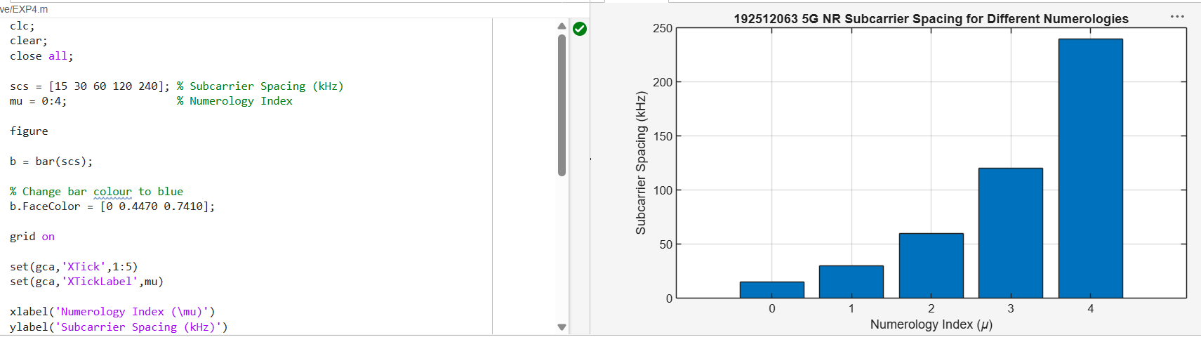
FIG.1.

Objective – 2 Compare Slot Duration

MATLAB Program
clear;
close all;
scs = [15 30 60 120 240]; % Subcarrier Spacing (kHz)
slot = [1 0.5 0.25 0.125 0.0625]; % Slot Duration (ms)
plot(scs, slot, 'o-', 'LineWidth', 2)
grid on
xlabel('Subcarrier Spacing (kHz)')
ylabel('Slot Duration (ms)')
title('5G NR Slot Duration for Different Subcarrier Spacing')
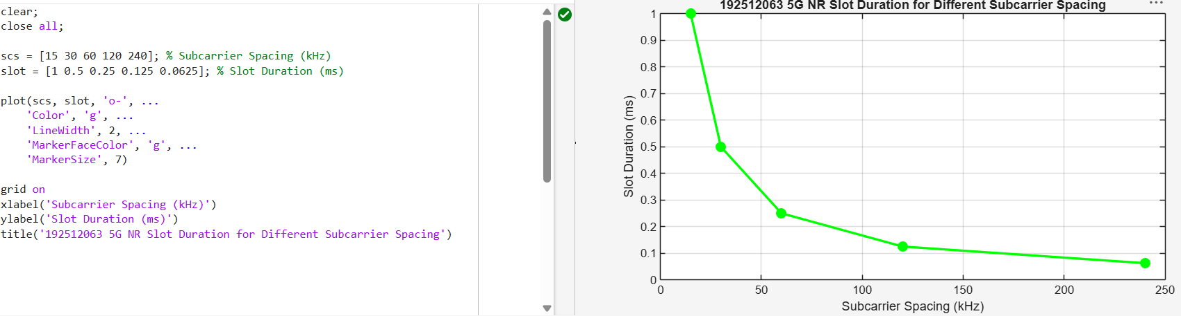

Objective – 3 Study the Number of OFDM Symbols

MATLAB Program
clc;
clear;
close all;
scs = [15 30 60 120 240]; % Subcarrier Spacing (kHz)
symbols = [14 14 14 14 14]; % OFDM Symbols per Slot
figure
bar(scs, symbols)
grid on
xlabel('Subcarrier Spacing (kHz)')
ylabel('Number of OFDM Symbols')
title('OFDM Symbols per Slot for Different Subcarrier Spacing')
ylim([0 16])
Expected Output
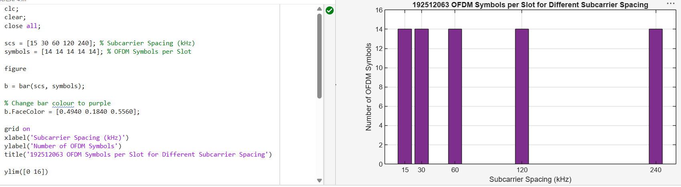
FIG.3.

